**Student Record Management System**

**Synopsis**

Department of Computer Engineering & Application

**Institute of Engineering & Technology**

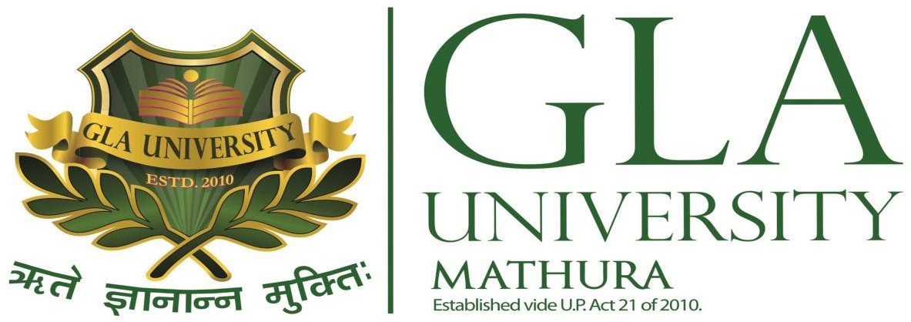

**Submitted To: - Submitted By: -**

**Mr. Vinay Agrawal Om Narayan Sharma** (181500839)

**(Assistant Professor) Kanhaiya Bhatt** (181500305)

**Badal Bhatt** (181500187)

# Acknowledgement

It gives us a great sense of pleasure to present the synopsis of the mini project (***Student Record System***) undertaken during B.Tech. 3rd Year, this project itself is going to be acknowledgement of the inspiration. Drive and technical assistance will be contributed to it by many individuals.

We owe special debt of gratitude to Mr. Vinay Agrawal(Assistant Professor, Department of CEA) for providing us with an encouraging platform to develop this project which thus helped us in shaping our abilities towards a constructive goal and for his constant support and guidance to our work. His sincerity, thoroughness and perseverance is being a constant source of inspiration for us. We believe that he will shower us with all his extensively experienced ideas and insightful comments at different stages of the project & would also teach us about the latest industry-oriented technologies.

We also do not like to miss the opportunity to acknowledge the contribution of all faculty members of the department for their kind guidance and cooperation.

Om Narayan Sharma(181500839)

Kanhaiya Bhatt(181500305)

Badal Bhatt(181500187)

## Introduction

a.What is Student Record System

b.About the project…

## Requirements

a.Hardware Requirements

b.Software Specifications

## Technology Used

## Future Prospects……………………………………..

This project completely functions for showing it as a prototype to anyone or to showcase in college projects. Features in the project include registering the Admin, Login Features, Adding Co-admin/moderators, Adding Student, View Students of particular college which is governed by the moderator, View Students details, View Student terms marks Edit/Modify the student, Delete Student from the record.

### Features Hierarchy

**Admin Control Structure**

* Add Co-Admin / Moderator
* View Moderators
* Add College
* Add Student
* View College Students
* View Students Details
* Edit Students Details
* Delete Student
* Login/Logout

**Moderator Control Structure**

* Login
* View all students Record added by admin
* Logout

****1. Admission Management****

The admission management module streamlines and automates every aspect of the admission process, including filling up online forms, batch allotment, and document submission.

It helps collect students’ information quickly as well as accurately.

****2. Attendance Management****

This module allows teachers to mark and view attendance of any respective students. Using the system, they can even share the attendance status of a student with their respective parents.

It also keeps track of staff members’ complete attendance records.

****3. Document Management****

Document management allows you to upload/enter complete students’ details. It includes contact details, parents’ details, report cards, health details, and more. All information is safely kept.

1. **Hardware Requirements(Minimum):**

1.**Processor**: i3 based or upto more

2. **RAM:** 2 GB minimum

3. **Hard Disk:** 5 GB Hard Disk Space

1. **Software Specifications(Minimum):**

**Platform:** Windows 10/Linux/Ubuntu/Mac

**Any Browser(One) Example:** Chrome/Opera/Edge

**Software:** Visual Studio Code/ Intellij or others

# Technology Used

---> Web based technology is used in this project.

1. HTML
2. CSS
3. JavaScript
4. PHP
5. MySQL as Database

**Future Prospects**

The proposed system is intended to make life easy. The main purpose of the project is to build a student database system to facilitate easy access of student’s records. The Student Database System will allow the registrar of GLA University, Login to edit, update students details records. It also enhances efficient management of student’s information and process and print out student’s transcripts/ result slips.